Assignment No : 7
- Step 1 : Setup Project

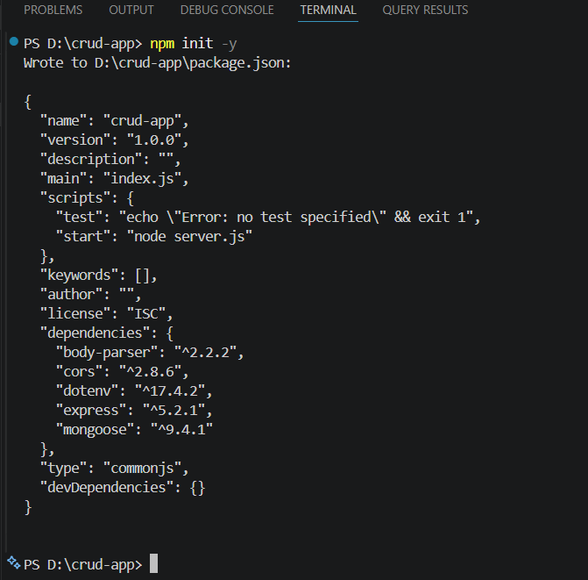

- Step 2 : Install Dependencies

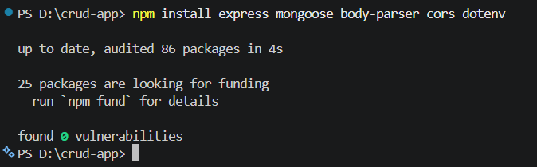

- Step 3 : Create Project Structure

- Server.js (for making connection with MongoDB):
const express = require("express");
const mongoose = require("mongoose");
const bodyParser = require("body-parser");
const cors = require("cors");
const app = express();
app.use(bodyParser.json());
app.use(cors());
// MongoDB Connection
mongoose.connect("mongodb://127.0.0.1:27017/studentDB", {
useNewUrlParser: true,
useUnifiedTopology: true
})
.then(() => console.log("MongoDB Connected"))
.catch(err => console.log(err));

app.use("/students", require("./routes/studentRoutes"));

app.listen(3000, () => {
console.log("Server running on port 3000");
});

- Students.js(Creating Model) :

const mongoose = require("mongoose");
const studentSchema = new mongoose.Schema({
name: String,
age: Number,
email: String
});
module.exports = mongoose.model("Student", studentSchema);
- studentsRoutes.js (Implement CRUD Routes) :

const express = require("express");
const router = express.Router();
const Student = require("../models/Student");

// CREATE
router.post("/", async (req, res) => {
const student = new Student(req.body);
await student.save();
res.send(student);
});
// READ
router.get("/", async (req, res) => {
const students = await Student.find();
res.send(students);
});

// UPDATE
router.put("/:id", async (req, res) => {
const student = await Student.findByIdAndUpdate(
req.params.id,
req.body,
{ new: true }
);
res.send(student);
});
// DELETE
router.delete("/:id", async (req, res) => {
await Student.findByIdAndDelete(req.params.id);
res.send("Deleted successfully");
});

module.exports = router;

- Step 4 : Run Server

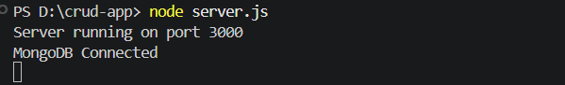

- Step 5 : Testing APIs

- POST (Create) :
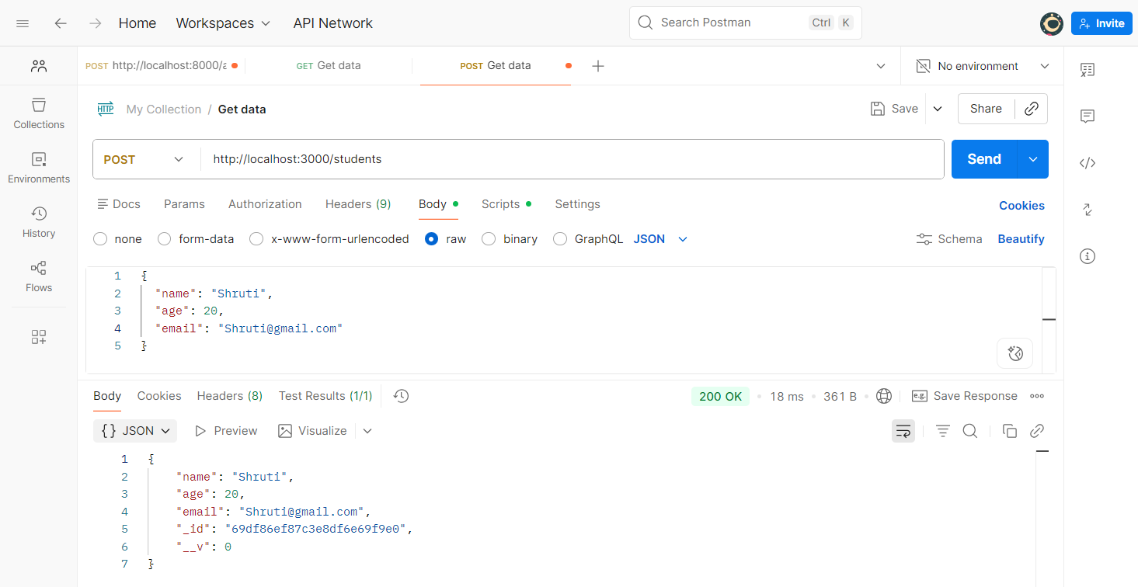
- GET (Read) :
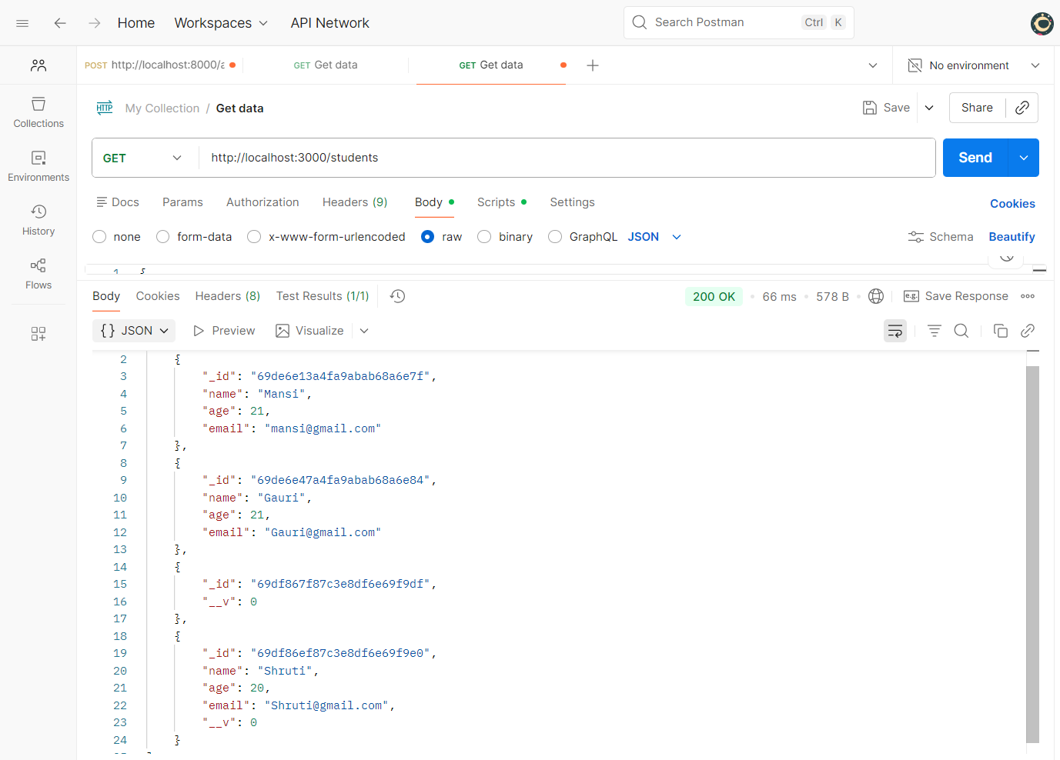

- DELETE :
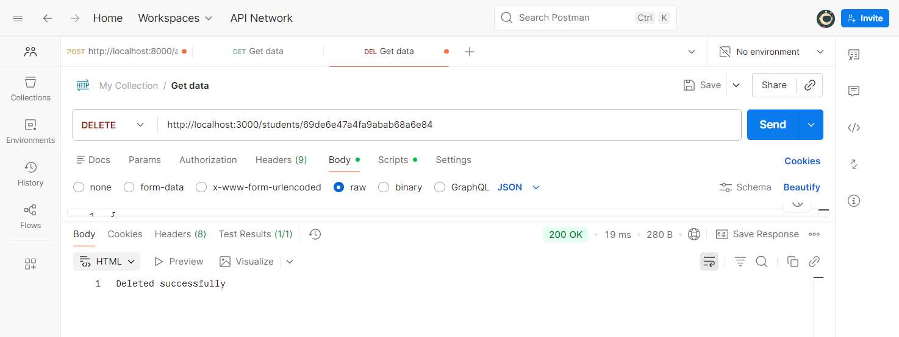

- Step 6 : Database
